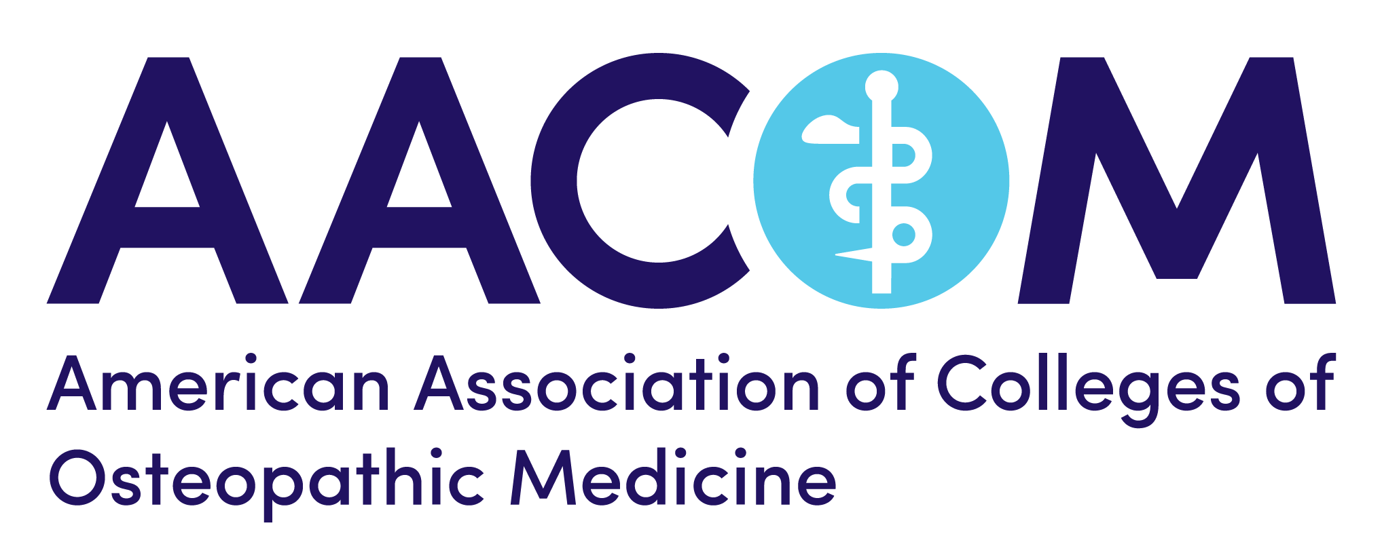
National Academy of Osteopathic Medical Educators (NAOME) Applicant Reference Check

NAOME Applicant’s Name:____________________________________________________________________________________________________
Scholarship Category:_________________________________________________________________________________________________________
Senior Administrator’s Name:________________________________________________________________________________________________
Senior Administrator’s Title:_________________________________________________________________________________________________
Senior Administrator’s Relationship to Applicant:________________________________________________________________________
The above-named applicant for selection into NAOME has listed you as a senior administrator in his/her educational institution/educational program. This person will submit an educational mini-portfolio representing his/her academic scholarship in one of the following four educational areas: teaching/evaluation; development of durable educational materials; educational leadership or educational research.
An NIH-like panel of reviewers will evaluate the candidate’s submitted portfolio to determine if it rigorously meets and sufficiently matches the appropriate standard-setting model of educational scholarship category. Note that induction as a NAOME Fellow is both an honor and a commitment to national service to the profession.
We are seeking your feedback regarding any relevant information that would suggest that this person would or would not be an appropriate applicant to be reviewed for induction as a NAOME Fellow. Please indicate your agreement with one of the following two statements below (you may attach an additional page of text to expand on your indication if desired) and return to Lynn Bragan, Lbragan@aacom.org.
☐ Based upon my knowledge and experience with this medical educator, I know of no professionalism issues that would preclude consideration of this person’s application to become a NAOME Fellow.
☐ Based upon my knowledge and experience with this medical educator, I can not support this person’s application to become a NAOME Fellow. I would be willing to have a phone conversation in this regard with the director of the AACOM Department of Medical Education who administers the NAOME program.

_____________________________________________________ ______________________________
Signature of Senior Administrator (Date)
_______________________________________________________________________
Contact phone number (optional)

Thank you for your assistance in both honoring and facilitating the national leadership of outstanding osteopathic medical educators.

